Voice over IP phones with CME

By: Jordan Abu-Zahra

**Summary**

In this lab we were given VoIP phones / Voice over Ip phone, and we were asked to set them up in a Lan and Wan configuration and have them be able to call outbound to real people, to complete this lab we must order a pizza and show it to our teacher.

**Background**

Voice over internet protocol (VoIP) is a technology that allows you to make telephone calls over the internet rather than through traditional telephone networks. VoIP converts analog audio signals (your voice) into digital data packets that can be transmitted over the internet. But there are different types of VoIP systems which include Hosted VoIP and this system uses a third-party provider that maintains the hardware and software need to run the service, and all the customers do is simply connect their phones to the internet to access the services. Another type is premises-based VoIP and this system needs customers to purchase and maintain their own hardware and software and this can include servers, gateways, and IP phones that the provide gives to you. And the final type is cloud-based VoIP and this system allows customers to use cloud-based services to make and receive calls, rather than having to maintain their own on premises hardware. VoIP has some perks that come with using it over traditional phones since its lower cos and has more flexibility since you can call from anywhere as long as you have an internet connection, and VoIP can be integrated with other business applications such as customer relationships management systems to improve workflow efficiency. Some of the limitations are quality of service (QoS) since calls are affected by internet congestion, resulting in low quality / dropped calls and power outages will not work since they rely of interne, and they can be vulnerable to hacking and other security threats.

In this lab we were told to use cisco unified communications manager express (CME) over Cisco unified communications manager (CUCM) they are quite similar since they are both cisco related software that are used to manage and control IP-based communications, such as voice, video and messaging. But the main difference between the both is that CUCM is for larger and more feature-rich systems that are meant for enterprise-level organizations with large and complex needs, and it is highly scalable since its able to support up to 100,000 users and help manage multiple sites. On the other hand CME is for smaller and simpler system that is designed for small to medium businesses with fewer uses and less complex communication needs, it can support up to 300 users and is for single site purposes.

**Topology**

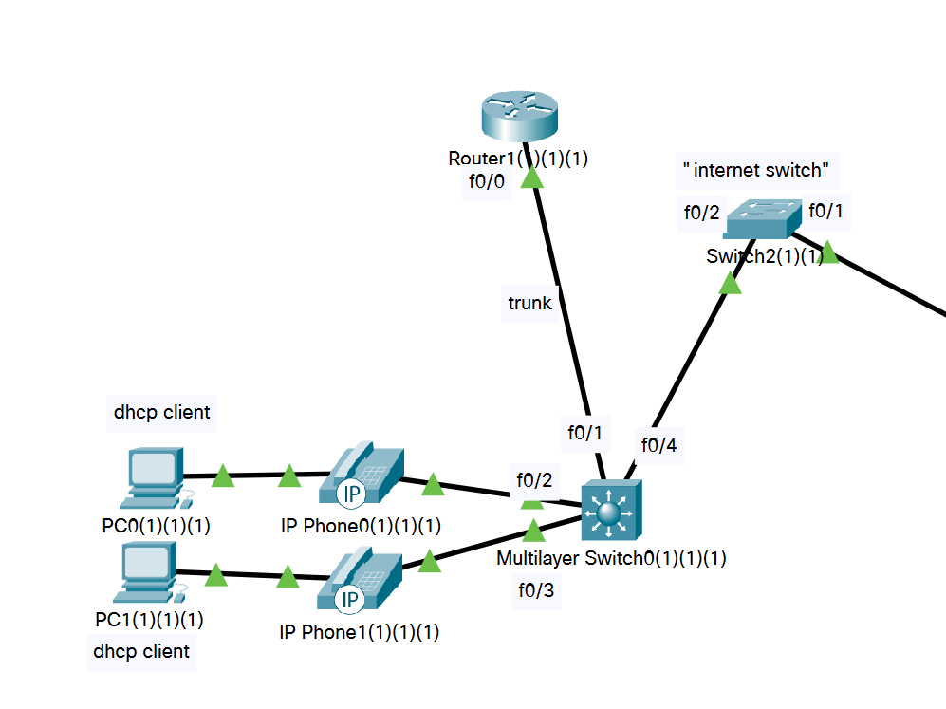

**Lab Commands**

**Switch**

**vlan 20:** creates a Virtual LAN

**name VOICE:** names the Vlan

**switchport trunk encapsulation dot1q:** creates a trunk connection to a router

**switchport trunk native vlan 50:** makes vlan 50 the native vlan so it takes the untagged traffic

**switchport mode trunk:** makes the switchport you are on a trunk

**switchport mode access:** makes the switchport go into access mode

**spanning-tree portfast:** (optional) speeds up the traffic of the port

**Router**

**ip dhcp excluded address (pool):** exclude a pool of address that can be assigned through DHCP

**ip dhcp pool (name):** assign a name for your pool

**option 150 ip (address):** helps the phone obtain a VoIP configuration usually coming from the TFTP server

**ip address dhcp:** the interface requests an ip address

**interface fastethernet0/0.20:** creates a sub interface

**tftp-server P00308000500.sbn:** send files to the phone

**voice-port 1/0/0:** the number for the FXO port

**ring number 3:** number of rings before port responds

**caller-id enable:** makes our number seen to the called

**connection plar opx 1010**: makes it so the voice port doesn’t answer until the remote side has answered

**forward-digits all:** forwards digits to the called

**dial-peer (number) pots:** creates a dial peer

**destination-pattern91[2-9]..[2-9]...... :** the dots represent the numbers that you dial and the 9 is to call out while the 1 is for the US country code

**telephony-service:** enables telephony service’s

**max-ephones2:** sets the max of 2 phones in the network

**ip source-address 192.168.20.1 port 2000:** source address for SCCP messages

**auto assign 1 to 2:** assigns dn numbers automatically to the 2 phones

**number 1010:** assigns number to the ephone

**mac-address:** sets the mac address for the ephone

**type (model):** model of the phone

**Configs:**

**Switch**

hostname Switch

boot-start-marker

boot-end-marker

no aaa new-model

system mtu routing 1500

vtp domain CCNP

vtp mode transparent

authentication mac-move permit

ip subnet-zero

spanning-tree mode pvst

spanning-tree etherchannel guard misconfig

spanning-tree extend system-id

vlan internal allocation policy ascending

vlan 10

name DATA

vlan 20

name VOICE

vlan 30

name MGT

vlan 40

name MISC

vlan 50

name NATIVE

vlan 99

name MANAGEMENT

interface FastEthernet0/1

switchport trunk encapsulation dot1q

switchport trunk native vlan 50

switchport mode trunk

interface FastEthernet0/2

switchport mode access

switchport voice vlan 20

spanning-tree portfast

interface FastEthernet0/3

switchport mode access

switchport voice vlan 20

spanning-tree portfast

interface FastEthernet0/4

interface FastEthernet0/5

interface FastEthernet0/6

interface FastEthernet0/7

interface FastEthernet0/8

interface FastEthernet0/9

interface FastEthernet0/10

interface FastEthernet0/11

interface FastEthernet0/12

interface FastEthernet0/13

interface FastEthernet0/14

interface FastEthernet0/15

interface FastEthernet0/16

interface FastEthernet0/17

interface FastEthernet0/18

interface FastEthernet0/19

interface FastEthernet0/20

interface FastEthernet0/21

interface FastEthernet0/22

interface FastEthernet0/23

interface FastEthernet0/24

interface GigabitEthernet0/1

interface GigabitEthernet0/2

interface Vlan1

no ip address

shutdown

ip classless

ip http server

ip sla enable reaction-alerts

line con 0

line vty 0 4

login

line vty 5 15

login

end

**Router**

hostname Router

boot-start-marker

boot-end-marker

logging message-counter syslog

no aaa new-model

memory-size iomem 10

no network-clock-participate slot 1

dot11 syslog

ip source-route

no ip cef

ip dhcp excluded-address 192.168.20.1 192.168.20.5

ip dhcp pool VOICE20

network 192.168.20.0 255.255.255.0

default-router 192.168.20.1

option 150 ip 192.168.20.1

no ipv6 cef

multilink bundle-name authenticated

voice-card 0

no dspfarm

voice-card 1

no dspfarm

vtp domain cisco

vtp mode transparent

archive

log config

hidekeys

vlan 10,20

interface FastEthernet0/0

ip address dhcp

duplex auto

speed auto

interface FastEthernet0/0.20

encapsulation dot1Q 20

ip address 192.168.20.1 255.255.255.0

interface FastEthernet0/0.50

encapsulation dot1Q 50 native

interface FastEthernet0/1

no ip address

shutdown

duplex auto

speed auto

interface FastEthernet0/0/0

interface FastEthernet0/0/1

interface FastEthernet0/0/2

interface FastEthernet0/0/3

interface Serial0/1/0

no ip address

shutdown

interface Serial0/2/0

no ip address

shutdown

clock rate 2000000

interface Serial0/2/1

no ip address

shutdown

clock rate 2000000

interface Serial0/3/0

no ip address

shutdown

clock rate 2000000

interface Serial0/3/1

no ip address

shutdown

clock rate 2000000

interface Vlan1

no ip address

shutdown

ip forward-protocol nd

no ip http server

no ip http secure-server

ip flow-export version 9

tftp-server P00308000500.sbn

tftp-server P00308000500.loads

tftp-server flash:P00308000500.bin alias P00308000500

tftp-server flash:P00308000500.sb2

control-plane

voice-port 1/0/0

ring number 3

connection plar opx 1010

caller-id enable

voice-port 1/0/1

voice-port 1/0/2

voice-port 1/0/3

voice-port 1/1/0

voice-port 1/1/1

dial-peer voice 82 pots

destination-pattern 9[2-9]..[2-9]......

port 1/0/0

forward-digits 10

dial-peer voice 83 pots

destination-pattern 91[2-9]..[2-9]......

port 1/0/0

forward-digits all

dial-peer voice 81 pots

destination-pattern 9[469]11

port 1/0/0

forward-digits 3

telephony-service

max-ephones 3

max-dn 2

ip source-address 192.167.20.1 port 2000

auto assign 1 to 2

max-conferences 8 gain -6

transfer-system full-consult

create cnf-files version-stamp Jan 01 2002 00:00:00

ephone-dn 1

number 1010

ephone-dn 2

number 1020

ephone 1

device-security-mode none

mac-address 001D.A219.FA62

type 7940

button 1:2

ephone 2

device-security-mode none

mac-address 0015.2B47.6685

type 7960

button 1:1

ephone 3

device-security-mode none

mac-address 001D.A219.F562

type 7940

line con 0

line aux 0

line vty 0 4

login

scheduler allocate 20000 1000

end

**Problems**

In this lab we had many problems and we had to solve them one by one since we had no idea what VoIP was or how to set it up at all, Lan was a breeze and we did not have any problems setting it up but trying to get it to call out was a very hard challenge and an example of a problem we had was that the CME tar files were not on our router, and we had to TFTP server it into our routes flash from another router that had it in a separate rack, another issue is that we did not know weather to plug our analog line into the FXO or FXS port so that was messing with our topology/configuration and we finally found it after days of research and found that it was the FXO port and also when we were getting close we had the command forward digits all which basically send out the digits you called through the analog line and we were trying to forward the amount of digits like forward digits 10 which was sending us to unwanted calling destinations so one we changed to forward digits all we were able to call out and complete our lab and order pizza for our signoff

**Conclusion**

In the end we were able to set up VoIP with CME and were able to call out to talk to people in other businesses like Dominoes and we learned how to use VoIP phones and use CME to help us call out, and our problems helped us gain more experience like using a TFTP server.